Direction: Make a powerpoint presentation with your assigned Socio and Political Philosopher. Here is the flow of the presentation: I. Introduction, II. Historical Background, III. Notable Works, IV. Socio and Political Theory, V. Conclusion, VI. References.

**TITLE SLIDE:**

Thomas Hobbes (1588-1679)

Philosopher and Political Theorist

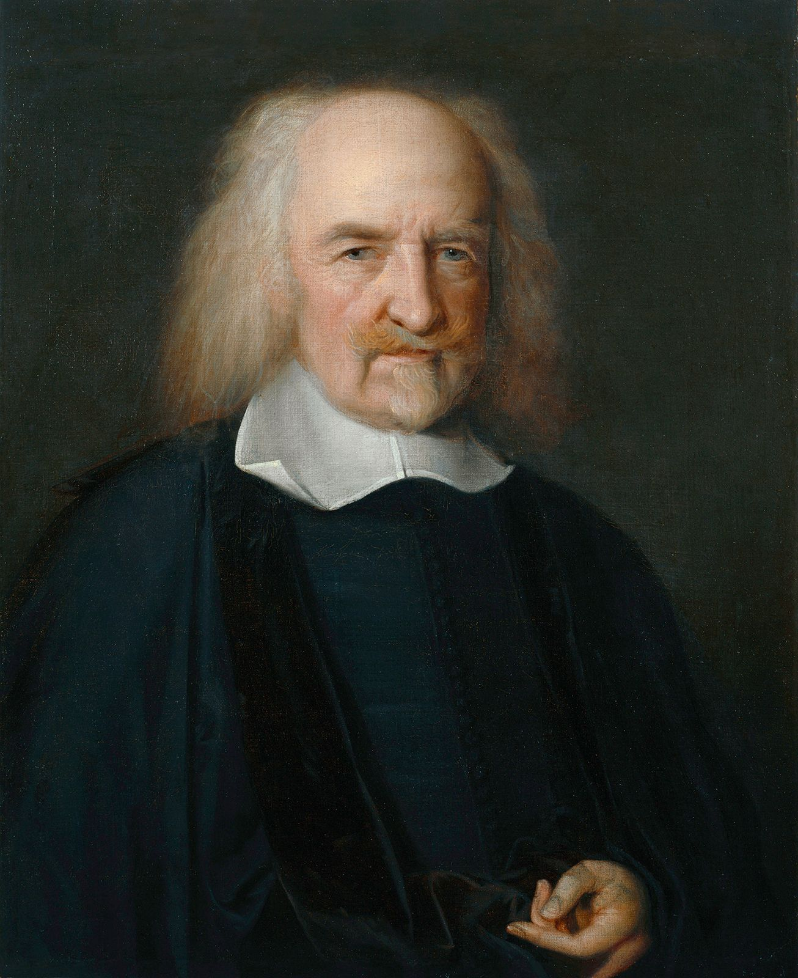

**INTRODUCTION:**

Thomas Hobbes was born in London in 1588. He received his college education at Oxford University in England, where he studied classics. He was one of the founding fathers of modern political philosophy. He is also best known for his political thought.

Thomas Hobbes was a prominent English philosopher and political theorist best known for his contributions to modern political philosophy. His seminal work, Leviathan (1651), laid the foundation for the social contract theory, exploring the structure of society and legitimate government. Hobbes’s ideas on human nature, the necessity of a strong central authority, and the social contract significantly influenced Western political thought.

**HISTORICAL BACKGROUND:**

Hobbes was an English philosopher whose political philosophy dominated the 17th century and continues to have a major influence today.

Thomas Hobbes was born in Malmesbury, Wiltshire, on 5 April 1588, the son of a clergyman. His father left the family in 1604 and never returned, so a wealthy uncle sponsored Hobbes' education at Oxford University.

In 1608, Hobbes became tutor to William Cavendish, later earl of Devonshire. The Cavendish family were to be Hobbes' patrons throughout his life. In 1610, Cavendish and Hobbes travelled to Europe together, visiting Germany, France and Italy. After Cavendish died, Hobbes obtained another position but later became tutor to Cavendish's son. During these years he travelled to Europe twice more, meeting leading thinkers including the astronomer Galileo Galilei and the philosopher Rene Descartes.

In 1640, with England on the brink of civil war, the Royalist Hobbes fled to Paris, fearing the reaction of the Long Parliament to his writing. He remained in exile for 11 years. Between 1646 and 1648, Hobbes was a mathematics tutor to Charles, Prince of Wales (the future Charles II) who was also in exile.

In 1651, Hobbes' best-known work 'Leviathan' or, 'The Matter, Form, and Power of a Commonwealth Ecclesiastical and Civil' was published. For Hobbes, the only way for man to lift himself out of his natural state of fear and violence was to give up his freedom and make a social contract with others to accept a central authority. Hobbes felt that a monarchy provided the best authority. He also argued that as sovereign power was absolute, the sovereign must also be head of the national religion. He was, as a result, hostile to the Roman Catholic Church.

This made him unpopular with the French authorities and in 1651 he returned to England. He continued to write, producing works on mathematics and physics as well as philosophy, and engaging in academic disputes. In 1660, his former pupil returned to England as Charles II and granted Hobbes a pension.

In 1666, parliament ordered 'Leviathan' to be investigated for atheist tendencies. Hobbes was terrified of being labelled a heretic and burned many of his papers. Charles II interceded on his behalf, but the condition seems to have been that Hobbes published nothing further on overtly political subjects.

In 1672, Hobbes published an autobiography in Latin verse and translations of the 'Iliad' and the 'Odyssey' in 1675-1676. He died on 4 December 1679 at Hardwick Hall in Derbyshire, one of the Cavendish family's homes.

**NOTABLE WORKS:**

* **Leviathan (1651):**

Hobbes's most famous work, Leviathan outlines his theories on the structure of society and legitimate government. It presents the idea of the social contract and argues for a powerful sovereign to ensure peace and prevent civil war.

* **De Cive (1642):**

Also known as On the Citizen, this work delves into political philosophy, focusing on the nature of human beings, the structure of civil society, and the necessity of political order. It serves as a precursor to some of the ideas later expanded in Leviathan.

* **The Elements of Law, Natural and Politic (1640):**

This work is an early expression of Hobbes's thoughts on human nature and political organization. It is divided into two parts: "Human Nature" and "De Corpore Politico," which explore natural law and the foundation of political society.

* **De Corpore (1655):**

Translated as On the Body, this book is part of Hobbes's trilogy on his philosophical system. It deals with metaphysical and logical topics, laying the groundwork for his materialist philosophy.

* **De Homine (1658):**

Translated as On Man, this work is the second part of Hobbes's trilogy and focuses on human nature and psychology, discussing the mechanisms of human perception, thought, and emotion.

* **Behemoth (1668):**

This work is a historical account of the English Civil War, examining the causes and events leading to the conflict. It provides Hobbes's analysis of political and social instability.

* **Translations of Thucydides' History of the Peloponnesian War (1628) and Homer's Iliad and Odyssey (1675-1677):**

Hobbes's translations of these classical works demonstrate his scholarly range and interest in history and literature.

**SOCIO AND POLITICAL THEORY:**

* **History and Politics: The Political Problem**

Hobbes' political philosophy begins with an analysis of human nature and society, which he famously summarized in his book "Leviathan." He saw human life in the state of nature as solitary, poor, nasty, brutish, and short. For Hobbes, this state of nature leads to a "war of all against all," where there's constant conflict and fear due to the absence of a common authority to enforce peace and resolve disputes. This leads to what he termed the "state of war," where individuals have a right to all things, including each other's lives.

The political problem, according to Hobbes, is how to escape this state of war and establish a peaceful and stable society. He argues that the solution is the establishment of a social contract, where individuals voluntarily give up some of their freedoms to a sovereign authority (the Leviathan) in exchange for security and order.

* **Scientific Views**

Hobbes was deeply influenced by the scientific advances of his time, particularly the works of Galileo and Descartes. He applied the methods of geometry and natural science to the study of politics and human nature, seeking to develop a systematic and rational understanding of society and government.

In "Leviathan," he presents his political theory as a deductive science, grounded in basic principles that can be derived from observations of human behavior and rational analysis. He believed that just as the laws of nature govern the physical world, there are also natural laws that govern human behavior and social relations.

* **Philosophy of Human Nature**

Hobbes' philosophy of human nature is central to his political theory. He posited that humans are fundamentally self-interested and driven by a desire for self-preservation. In the state of nature, this leads to a perpetual state of conflict as individuals compete for resources and security.

However, Hobbes also believed that humans are rational beings capable of recognizing their own self-interest and the benefits of cooperation. This forms the basis for his argument for the social contract and the establishment of civil society. By voluntarily submitting to the authority of a sovereign, individuals can escape the chaos of the state of nature and achieve peace and security.

* **Science of Politics**

Hobbes believed that politics could be studied and understood in the same way as the natural sciences. He sought to develop a scientific approach to politics based on observation, reason, and empirical evidence. This approach is evident in his systematic analysis of political theory in works like "Leviathan," where he applies principles of geometry and natural law to the study of government and society.

Overall, Hobbes' socio-political theory is a comprehensive framework that addresses the fundamental problems of human nature, society, and politics. It remains influential in contemporary political thought and continues to provoke debate and discussion about the nature of power, authority, and social order.

**CONCLUSION:**

Thomas Hobbes's contributions to political philosophy and social theory have had a profound and lasting impact on our understanding of human nature, society, and government. His analysis of the state of nature as a condition of perpetual conflict and his proposal of the social contract as a solution to the political problem laid the groundwork for modern political thought.

Hobbes's emphasis on the importance of a strong, centralized authority to maintain order and security has influenced subsequent theories of government, particularly those advocating for absolute or authoritarian forms of rule. His belief in the rationality of human beings and the application of scientific methods to the study of politics paved the way for the development of empirical political science.

However, Hobbes's ideas have also been subject to criticism and debate. His portrayal of human nature as inherently selfish and his defense of absolute sovereignty have been challenged by those who argue for the importance of individual rights and democratic governance.

Nevertheless, Hobbes's work remains essential for understanding the origins of modern political theory and continues to be studied and debated by scholars and thinkers across disciplines. His insights into the nature of power, authority, and social order continue to shape our understanding of politics and society to this day.

**REFERENCES:**

Nguyen, N. (2023, December 26). *Thomas Hobbes: Politics, Philosophy and Ideas*. TheCollector. https://www.thecollector.com/thomas-hobbes-lifes-work/

*Hobbes, Thomas: Methodology | Internet Encyclopedia of Philosophy*. (n.d.). https://iep.utm.edu/hobmeth/#:~:text=Hobbes%20also%20considers%20humans%20to,all%E2%80%9D%20(L%20186).

Sorell, T. (2024, April 1). *Thomas Hobbes | Biography, Philosophy, Beliefs, Leviathan, Legacy, & Facts*. Encyclopedia Britannica. https://www.britannica.com/biography/Thomas-Hobbes